**Documentation**

1. Description of Functionalities
   1. Add a User
2. Validation of Web Page
   1. First Attempt

There are two errors in the html, while there is no error in the CSS file. I created a folder named ‘js for functions’ to pack the javaScript files. The folder name contained some space. However, when I reference the executable script, the space in path segment is not allowed, which caused the errors.

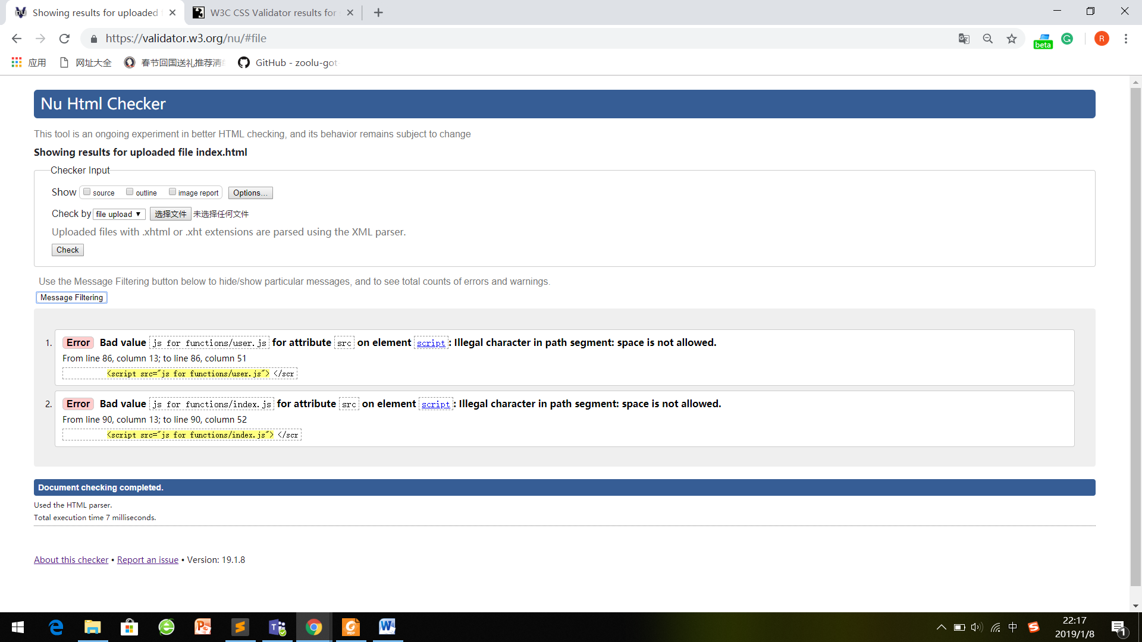

The Result of HTML

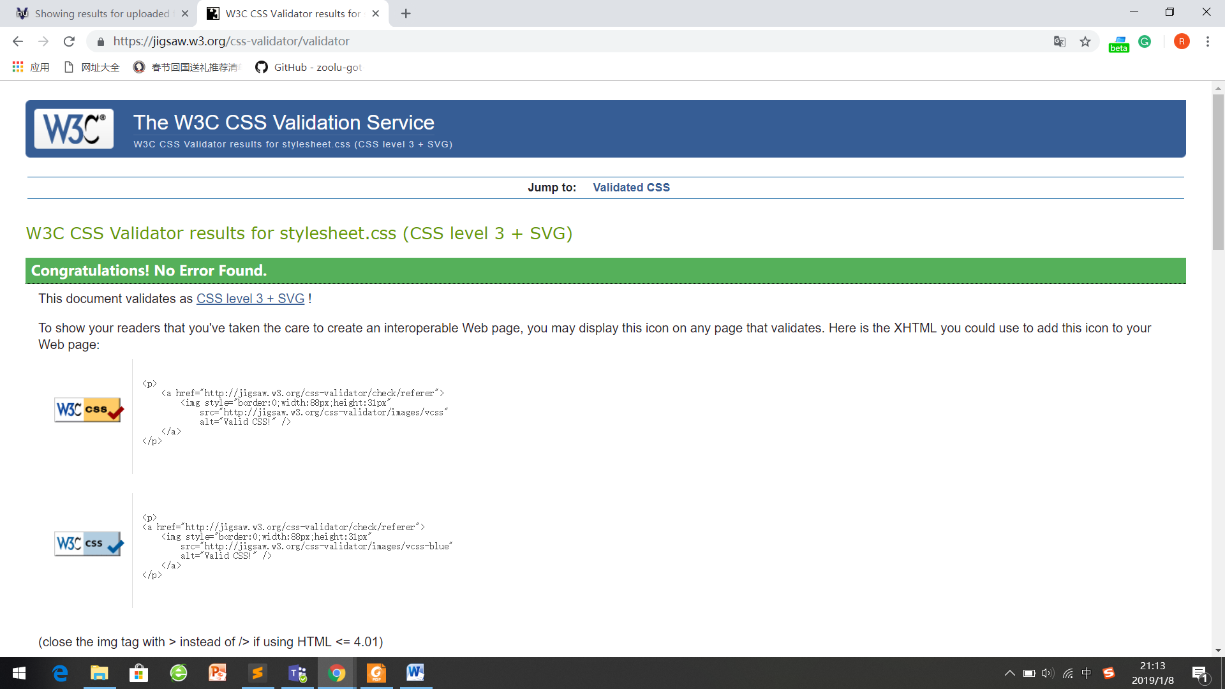

The Result of HTML

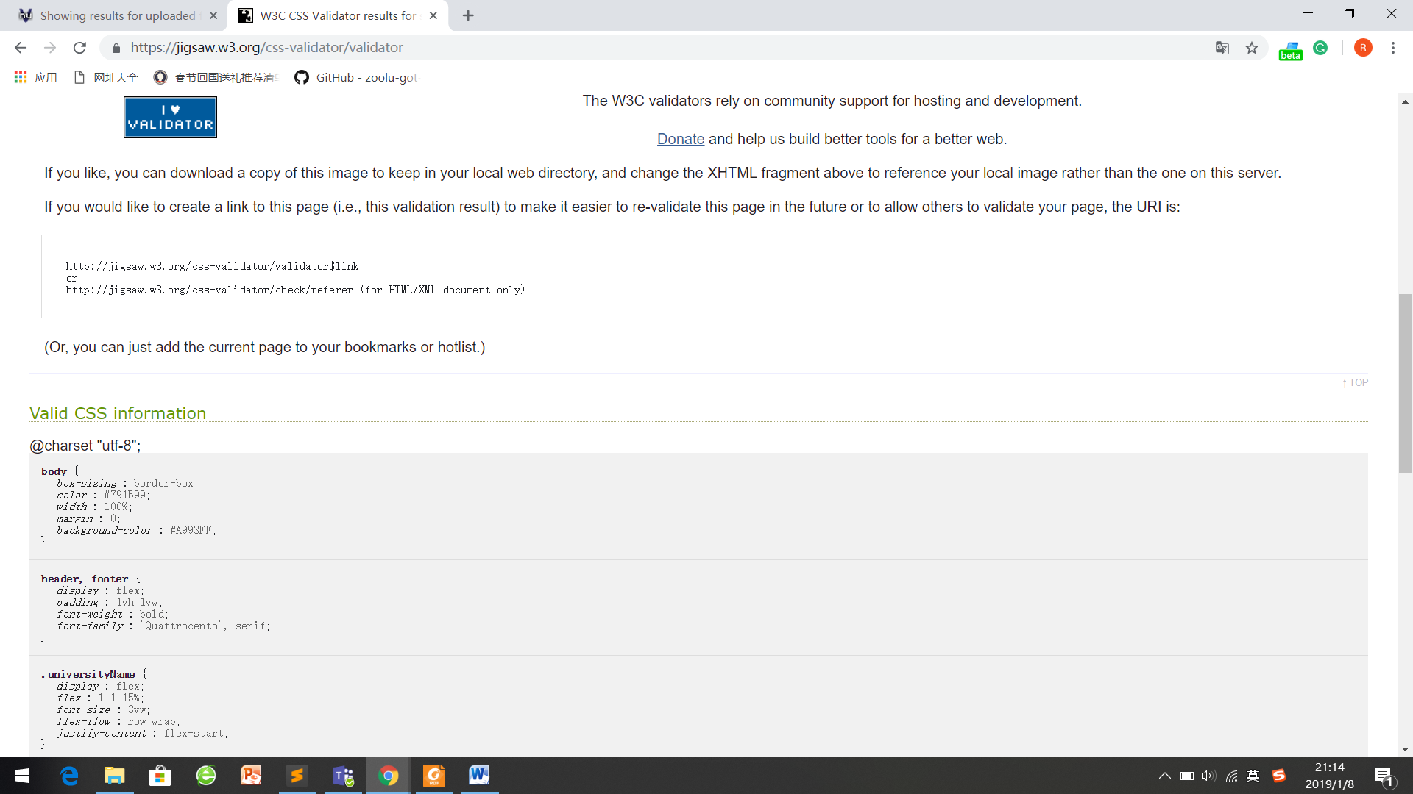

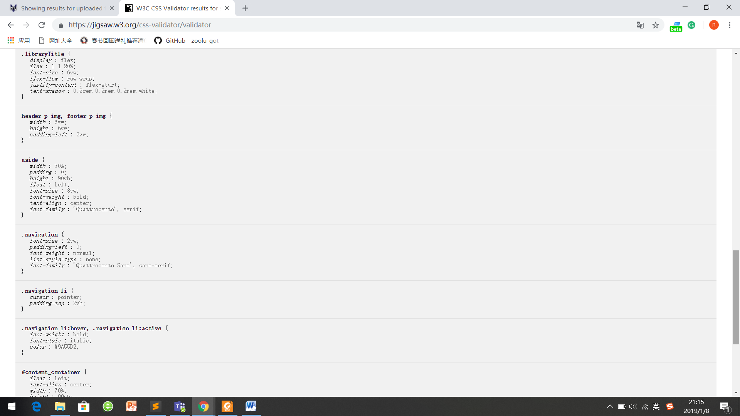

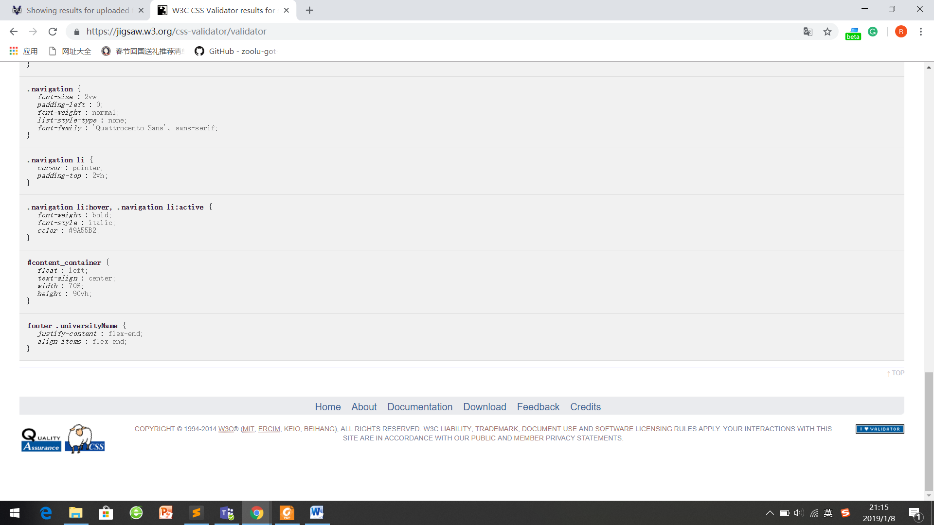

Valid CSS Information

* 1. Second Attempt

After renaming the folder and changing the path in the html file, there is no error or warning, according to the checker.

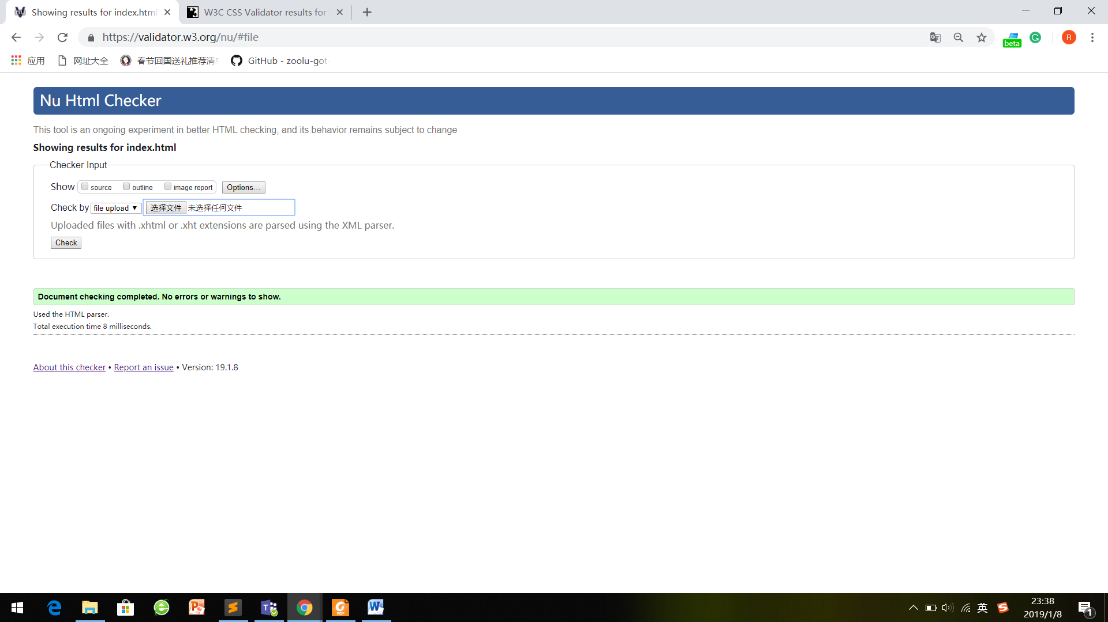

The Result of HTML